Chatbot Development

J. Mohammed Sumhoon1, Dr. P. Arun Kumar2

1PG Scholar, 2Assistant Professor

*Department of MCA, E.G.S Pillay Engineering College (Autonomous)*

1[mohammedsumhoon24@gmai.com](mailto:mohammedsumhoon24@gmai.com)

2[parunkumar@egspec.org](mailto:parunkumar@egspec.org)

*Abstract* **- A chatbot is an artificial intelligence computer program which performs communication using text and audio system. A person can ask any questions and chatbot will answer accordingly. Nowadays a chatbot is highly popular and takes speed as a computer communication application. A chatbot is used in many areas like order food, product suggestions, customer support, weather, personal finance assistance, scheduled a meeting, search and track flights, send money, and many more.**

**The main objective that we will discuss in this paper is about creating a chatbot to check order status using Natural Language Processing (NLP) with python platform, in this research paper we are trying to understand the Chatbots and understand their shortcomings.**

***Keywords* – Chatbot, Natural Language Processing (NLP), Machine Learning, Artificial Intelligence, JSON file.**

I. INTRODUCTION

Chatbots are not a recent development. They are simulations which can understand human language, process it and interact back with humans while performing specific tasks. The first chatbot was created by Joseph WieZenbanum in 1966, named Eliza. Today, almost all companies have chatbots engage their users and serve customers by catering to their queries. Famous chatbots like Google Assistant, Amazon Alexa, Siri, Facebook, Slack, and many more are in trend. These are very much helpful, but in this era of enhancing technology, day by day technology gets updated, and accordingly, user expectations also increase. As per a report by Gartner, chatbots will be handling 85% of the customer service interactions by the year 2020. A user wants more automation in the chatbot. Chatbot can be described as an answering system where a system will be able to answer questions or statements submitted by users and allow users to control over the content to be displayed. A bot is trained on and according to the training, based on some rules on which it is trained, it answers question.[5]

II. CHATBOT FEATURES

1. *Simple & Fast Integration*

Chatbot using Machine Learning can be seamlessly integrated with any existing business messaging channel such as SMS, WhatsApp, Facebook, etc. This enables you to serve your audiences on their preferred platform.

1. *Quicker Response Rate*

AI chatbot online are smarter and automated. They act fast based on customer interests and allows businesses to gain customer insights and data to trigger better engagement.

1. *24*7 Support*

Chatbots are live round-the-clock, enabling you to provide instant responses to your customer queries. This helps create a consistent brand value, even during non-business hours.

1. *Individualised Experiences*

Chatbot using Machine Learning are intelligently designed to understand each customer’s interests, delivering a personalised experience and helping them find what they are looking for.[5]

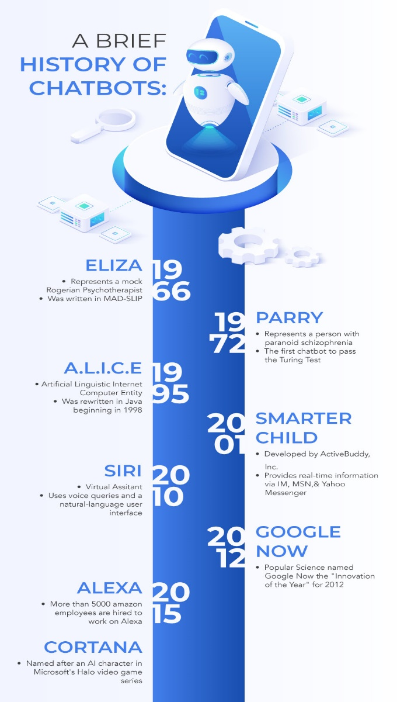

Fig. 1 History of chatbot

III. TYPES OF CHATBOT

In our study of chatbots, I found that there are three major types of chatbots, these are [1]

1. Rule Based model
2. Retrieval Based model
3. Generative Based model
4. *Rule Based Model*

This type of chatbots will work by searching for specific keywords in inputs given by a user. The keywords will be used to understand what action the user wants to take (user’s intent). Once the intent is identified, the bot will then pick out a response appropriate to the intent.

1. *Retrieval Based Model:*

This type of chatbots work on the principle of graphs or directed flows. The chatbot is trained to provide the best possible response from a database of predefined response. The responses are based on existing information.

1. *Generative Based Model*:

This type of chatbots is an open domain chatbot program that generates original combinations of language rather than selecting from predefined responses.

Which has large amount of conversational training data.

IV. METHODOLOGY

Chatbot is implemented using Generative Based approach, by Natural processing Language. The block diagram of the proposed system is elaborated in Fig-2. The chatbot is developed to return the most similar data from the corpus, based on query.[2]

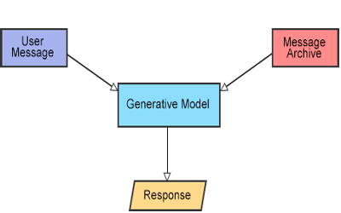

Fig 2. Chatbot proposed System

1. *NLP*

Natural language processing is a branch of AI, which deals with the interaction among machines and human spoken languages. NLP is used to analyze and understand the user’s input. Using NLP computer can perform several tasks like knowledge extraction, sentiment analysis, speech recognition, fake news deduction. NLP was developed by a set of mathematical rules which in turn developed with Machine Learning algorithms for language processing. [3][5][6]

B. *Data Preprocessing*

Data processing is the most important step when it comes to machine learning. Machines does not understand the data as humans, that is the reason data must be preprocessed. Data preprocessing also has some important steps as well,

*1) Letter Case*: The completer corpus of predefined responses or user responses must be in a single case, preferably lower case. Which process helps the algorithm used in the chatbot not treat the same words in both cases as different and maintain uniformity.

*2) Tokenization*: It is used to describe the process of converting the normal text into a list of tokens that can be further processed. Sentence tokenizer and word tokenizer are used to make a list of tokens from words and sentences respectively.[3]

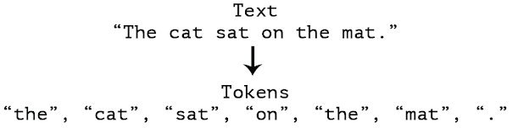

*3) Remove Noise*: Everything other than the standard number or letter should be removed.

*4) Removing Common Words*: The common words that are of negligible value and help select and match the user needs have to be excluded. These words are also called stop words since they are the words where the machine literally stops analyzing.

*5) Lemmatization:* The process which reduces derived words to their stem and root form. For example, “Writes”, “Writing”, ”Written” and “Wrote”, it would result in single word “write”.[3]

1. *User Request Analysis:*

In this step, chatbot analyses the queries requested by the user and recognizes the user intent to extract relevant data objects. Without intent the application will not return a righteous response.

The word embedding based on the frequency is used to predict the appropriate response.[4]

1. *Returning Response:*

Once the intent of the query is correctly interpreted. The application can now respond to the user’s query. In this particular system, the answer can be

* A Predefined response, encoded in the program.
* A text retrieved from the corpus (Knowledge-base)

Once the intent of the query is correctly interpreted, the application finds it easy to respond based on various machine learning approaches.

The features extracted based on the frequency using TfidVectorizer are compared using the cosine similarity. Therefore, in this system the heuristic used in the system is frequency. The most similar sentence is selected as an output from the corpus, based on the calculations from TfidfVectorizer and cosine similarity [2][4].

V. MATHEMATICAL MODEL

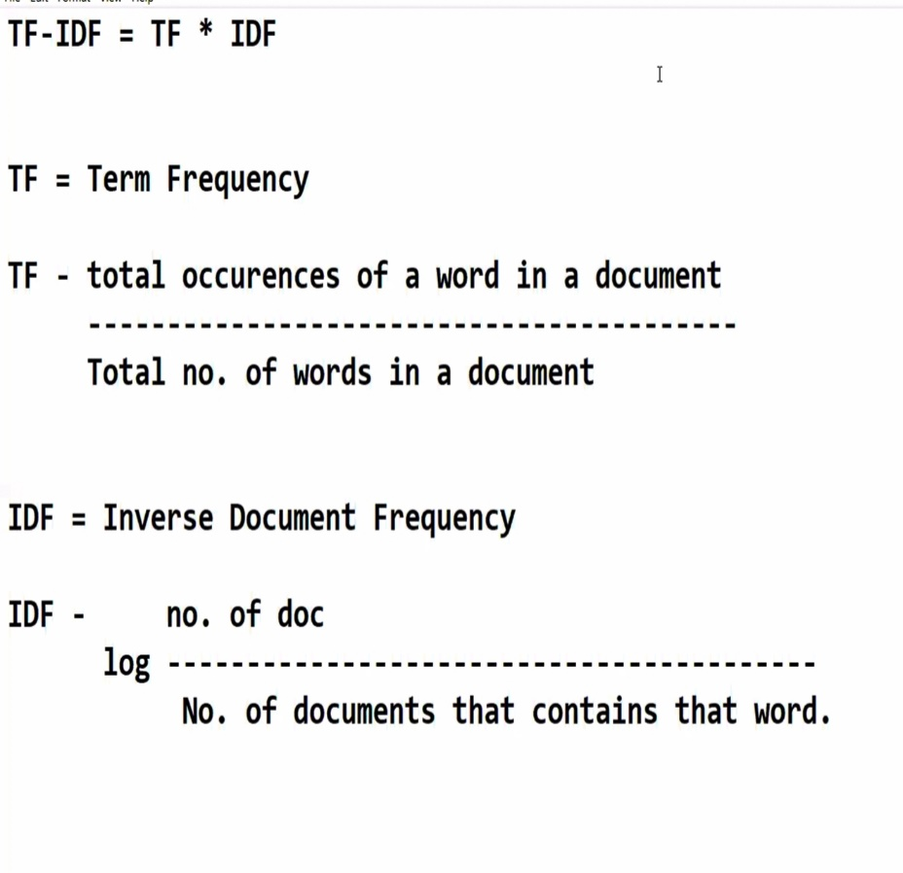

Fig 3. Mathematical representation of chatbot process

VI. CHATBOT ISSUES AND SOLUTIONS

*1) Conversations with chatbots are* *poor:* Chatbots are not that good at keeping up a conversation. Their pre-established number of answers and reactions is limited. Let's take a booking bot for example. You surely get the basic questions answered and the simplest suggestions pushed, but if you go into detail, you most probably will need to make a research by yourself.[4]

***solution:*** Create a chatbot service with built-in AI. Such an intelligent chatbot learns from all the collected interactions and improves over time. These kinds of intelligent chatbots support more diverse conversations and can even at times crack jokes in the right context. What's more? A survey found that 77.14% of the people are comfortable chatting with an AI bot.

**2) *You don't always need a chatbot****:* Following the problem number 1, there is one more to mention. Sometimes you just want to talk to a real person instead of a robot. Depending on what type of help you need from a chatbot service, sometimes it just can't cover all your needs. For example, consider you want to buy clothes online, so you ask the chatbot to filter results according to your shopping requirements. However, there are times like queries related to size, when chatbots fail to give correct answers. There are numerous cases like this when you realize talking to a real person could solve any of your issues much faster.

***Solution:*** There's little you can do to make people use only chatbots. Once conversations with machines are sophisticated enough to cover all user needs, this problem will be diminished. Make your chatbot smart.

## **3) *Poor chatbot maintenance:*** So you have decided that you really need chatbot technology for your business as almost every business including your competitors is using it. You hire an offshore dedicated team and they create a chatbot. After you implement it, you see how people started using it, and you suppose everything is fine now. Then, you forget about your chatbot at all and focus on other business tasks. Some users start complaining that something doesn’t work but you just don’t have time to fix that. Moreover, you don’t want to invest in hiring a proper support team, so you just let it go. This leads to fewer and fewer people using the chatbot, hence its purpose to is questionable.

### ***Solution:***If you have decided to implement technology to achieve some goal, make it the main focus not only till it’s done, but also after the release. Establish continuous working support and maintenance for your chatbot solution. Don’t forget about regular updates and improvements.[1]

### VII. **CHATBOTS ARE THE FUTURE**

### Chatbots can be really useful and great entertainers. With tremendous improvements in the last 2-3 years in natural language processing technologies', we can only expect chatbots becoming our savvy everyday cronies.

### Many multinational top mobile app development companies have already jumped the chatbot train and are providing excellent native chatbot development services for Android & iOS apps to clients.

VIII. CONCLUSION

In this Research, we have introduced a chatbot that is able to interact with users. This chatbot can answer queries in the textual user input. The chatbot can answer only those questions which he has the answer in its dataset. So, to increase the knowledge of the chatbot.

REFERENCE

[1] K. Jwala, G.N.V.G Sirisha, G.V. Padma Raju “Developing a Chatbot using Machine Learning” International Journal of Recent Technology and Engineering (IJRTE) Volume-8 Issue-1S3, June 2019.

[2]

https://scikitlearn.org/stable/modules/generated/sklearn.feature_ extraction.text.TfidfVectorizer.html

[3] R. Dale, “The return of the chatbots,” Natural Language Engineering, vol. 22, no. 5, pp. 811–817, 2016.

[4] H. Blog, “Voice or text: deciding and designing a user firs chatbot,” U.D. a. H. Jagrat Ed., ed.

[5] https://en.wikipedia.org/wiki/Chatbot

[6] Akshay Kulkarani & Adarsha shivananda, “Processing Recipes: Unlocking Text Data with Machine Learning and Deep Learning using Python”, September 2019